BARTON FESTIVAL 2025

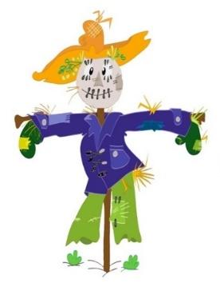
30th August & 31st August

Your name
Your address
Contact details
Category:
Adult / Family / Clubs / Business
Name of entry

Please return entry to Victoria.Sylvester@ewemove.com
Scarecrow Entry Form

We all know that the real stars of the Festival are our wonderful scarecrows, and they get better every year!

Thank you for getting stuck in. We can’t wait to see your entry. Do remember to get it out nice and early, our judges are on the lookout from a fortnight before the event.

Good luck!

